**MSSE 500 - Assignment Submission Document**

Name: David Freeman

Date: 9-24-2017

I. Assignment Name: Build and/or Modify: Memory Game

II. Learning Objectives:

* Be able to utilize user interactions in order to change displayed information and change displayed information according to certain conditions.
* Be able to monitor and modify real-time data.

III. Abstract -

For the week 4 assignment I modified the Matching Game from chapter 5. For the new images I went to pexels.com, they have a large selection of images that are free and under the creative commons license meaning it is acceptable to use them for homework or even commercial use. I then resized all of the images as they were all very large in order to reduce the file size. To edit the images, I used an open source image editor called GIMP. I then modified the author’s array of image sources to the new, resized images. There is a total of ten pairs or, twenty images that the player will have to match. When choosing the images, I chose pairs that were similar in their category, pictures of animals, or two pictures of similar scenery. Once the player makes all of the matches they will see the time it took to do so and a button created with JavaScript will become visible. A click event listener will be attached and when click the page will be reloaded using location.reload(). This is something I hadn’t used before and I liked giving this option to the player instead of making them click on their browser to reload the page.

IV. Statement of Originality

The code for this project was taken from the provided code on GitHub and modified by myself. To create the button element and use the reload method of location I used W3Schools and MDN for research.

V. 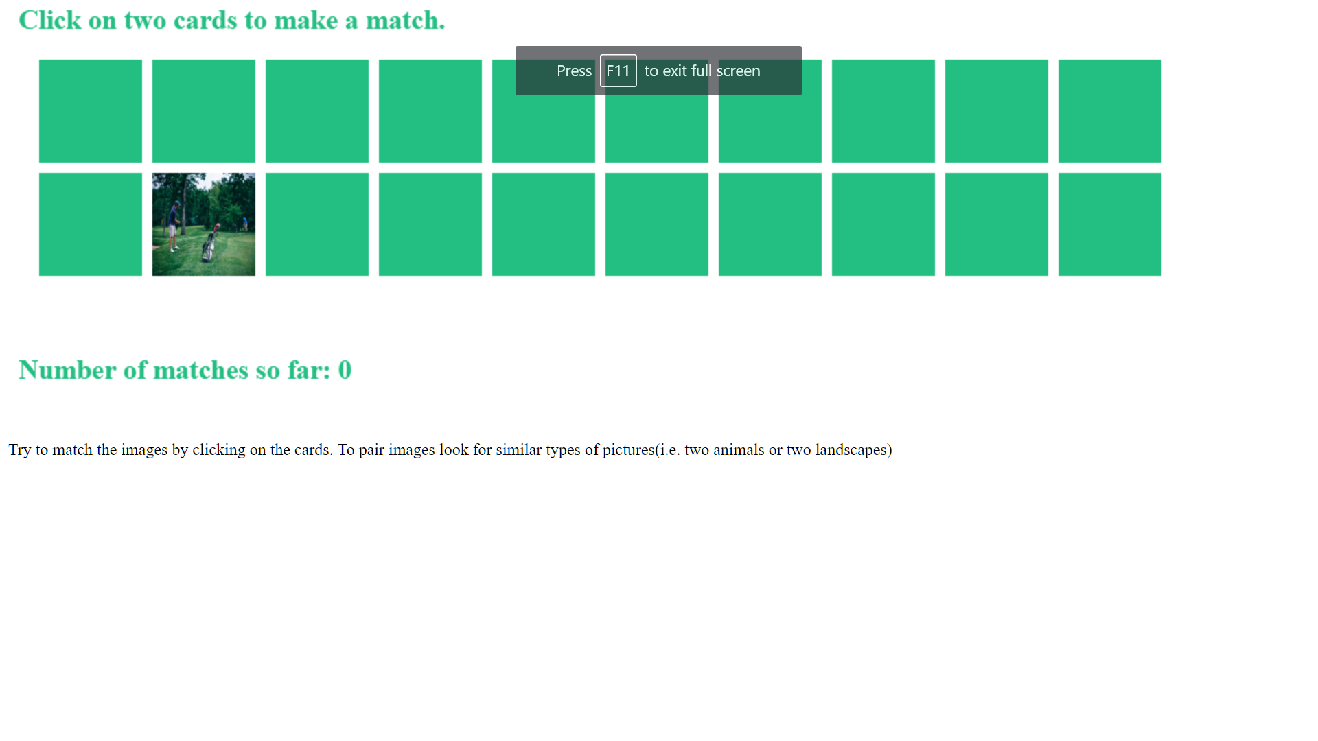

Figure 1: Screenshot of gameplay

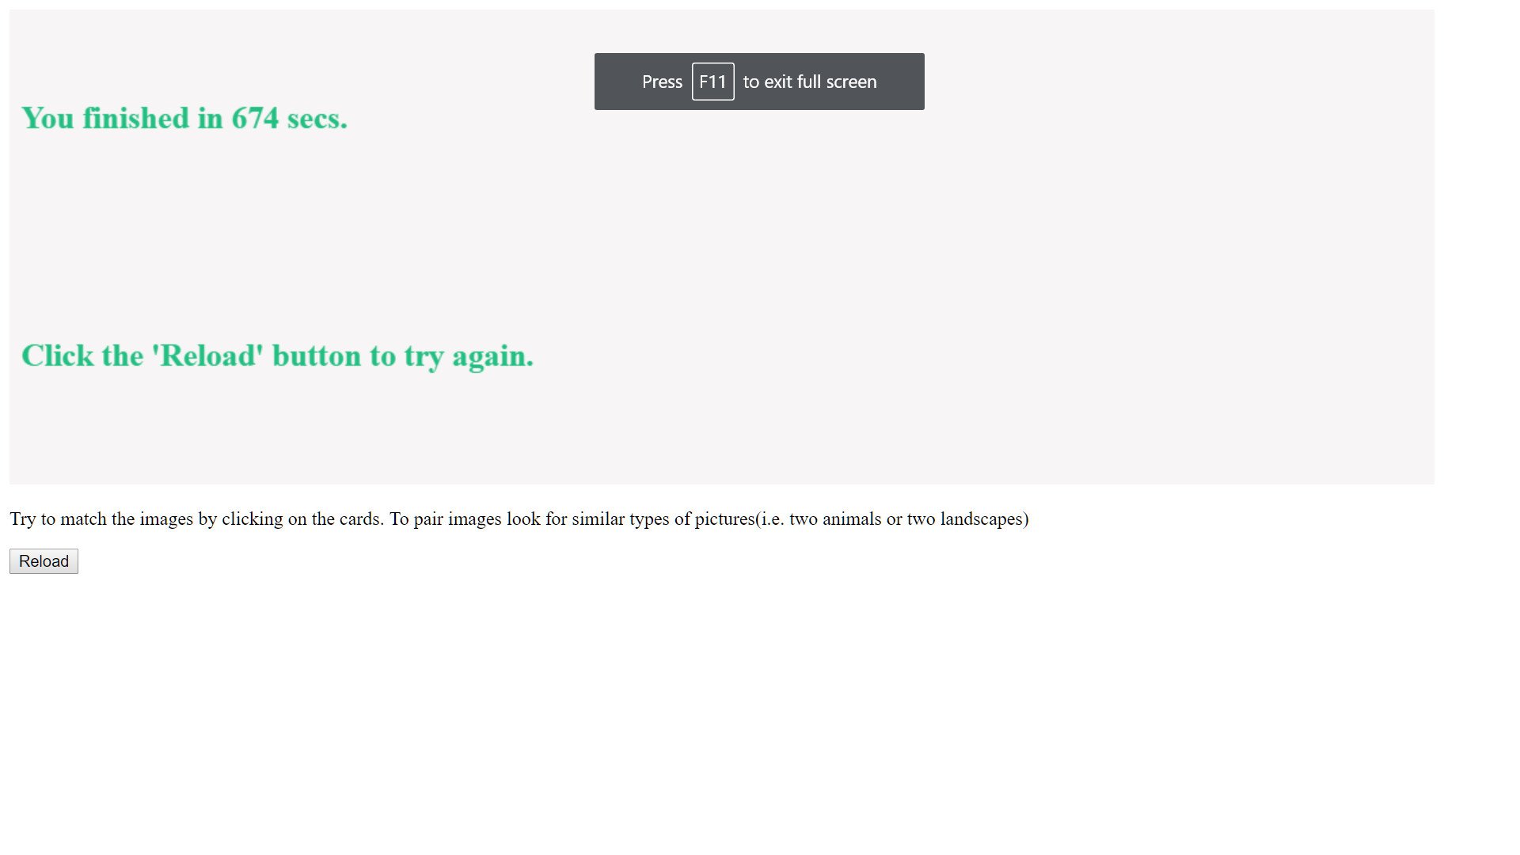

Figure 2: Screenshot of completed game

VI.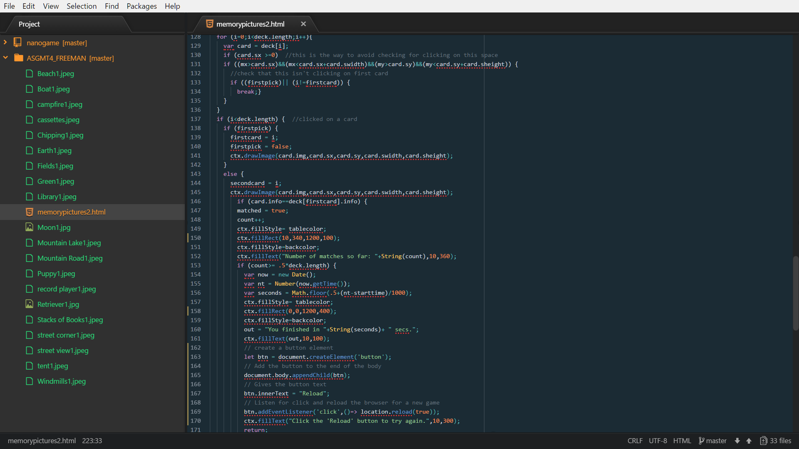

Figure 3: Screenshot of code editor Note: *The code shown here is the original code from the Meyer, 2010, chapter 5 memory game example that has been modified by me.*